Operation & Maintenance Manual

FOR

SHRINK TUNNEL&
L-BAR SEALER

Prepared By:

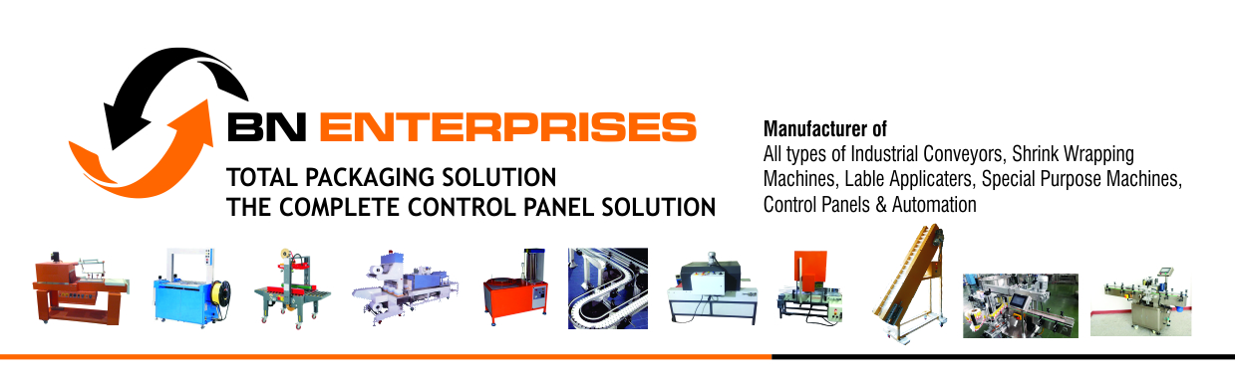
Greeting from B N ENTERPRISES an ISO 9001:2015 certified company.
GATE NO.20/A, NEAR KHED SHIVAPUR INDUSTRIAL ESTATE, ARVI VILLAGE,TAL -HAVELI, PUNE, PUNE
Mob. no 8308746511/9607993690
Office No 8308772458/9607993695/94
Web Side : www.bnenterprises.net
www.bnpackagingspm.com
Emil ID: inf.bnenterprises@gmail.com

Chapter 1
INTRODUCTION

We thank you for choosing this machine for your packaging needs and welcome you to our increasing group of satisfied clients. The Shrink Tunnel provides a versatile high performance solution. These machines are the result of our long years of experience in this field and great emphasis is placed on use of reliable materials and assembly techniques to ensure low maintenance and operational costs. By purchasing these machines, you also put at your disposal our technical services.

1.1 Use of Operating Manual

This manual provides detailed instructions and information on the use and maintenance of Shrink Tunnel.

Please read this manual completely and understand its contents before attempting to install and operate this machine. This is essential for the operator’s safety and prevention of any damage to the machine during operation. This manual must accompany the machine and is an integral part of it. No portion of this manual can be altered or removed.

We reserve the right to alter any portion of the manual as we see fit in order to improve the understanding of the manual and you must ensure that any amendments sent are included in the manual. We also reserve the right to make modification to the machine and the manual without advising the users.

1.2 Structure of the Manual

In order to make this manual easier to consult, it is divided into different sections and sub-sections in a logical manner describing the all the basic features required to operate and maintain these machines in a safe manner for both operator and machine.
The contents page provides the list of sections and sub-sections with the page numbers where the relevant information may be found.

1.3 General Safety Instructions and Definitions

Before working with the machine, the operator must understand the characteristics and function of the machine along with the location and use of its controls and should read the operating manual completely.
When in doubt regarding any section, contact directly to the authorised Technical Service of the manufacturer. Do not operate the machine in case there is any doubt on the correct interpretation of these instructions and contact the manufacturer for the necessary explanation.
Any non-observance of the regulations and recommendations included herein releases the manufacturer from the liability for any damages either direct or indirect.

Please ensure these general precautions are maintained at all times for the proper safety of operator and machine:

- Do not install or operate the machine is areas having risk of fire or explosion.
- Do not remove or modify any of the safety features or elements installed on the machine.
- Do not touch any moving part of the machine.
- Do not carry out any electrical work on the machine without disconnecting the main power supply.
- Do not make any modifications on the machine without the prior consent of the manufacturer.
- Do not use any material or product on the machine without checking its suitability.
- Do not operate the machine wearing loose clothing, chains or any other article that pose a hazard of getting caught in moving parts.

1.4 Warning Symbols and Legends used

 | Warning. Please pay attention to the instructions.
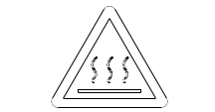 | Caution. Hot surface. Temperature may be high enough to cause burns
 | Caution. Electric shock possible. There exists high voltage sufficient to cause electrocution.
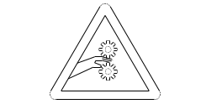 | Caution. Crushing danger. Pinch point.

1.5 Warranty

The machine has been assembled using high quality components and has successfully passed all tests in compliance with present regulations prior to shipment from our factory.

The machine is covered by a warranty against any defective components or manufacturing defect for a period of one year from the date of installation at the customer premises provided the machine was properly installed and used as per instructions given in the Operating Manual. The warranty is limited to the free replacement or repair of the defective part. It does not cover transport, travel or workmanship charges which must be paid by the Buyer. The work under warranty must be carried out either by the manufacturer or their authorised agent.

The warranty is void under the following conditions:
- If the machine was not properly installed or connected to wrong power supply.
- If the machine was damaged due to accident or misuse by unauthorised personnel.
- If modifications have been done on the machine without the prior approval of the manufacturer.
- If the machine is used in an environment that is not suited for its operation.

Chapter 2
Machine Information

2.1 Technical Specification

Feature | SHRINK TUNNEL
Conveyor Length | PTFE Coated Mesh Type Conveyor Belt, Meter Live 5420MM L + 500 MM W
Shrink Zone Size | 16”(Height) X 26”(Width) X 50”(Length)
Product dimensions (max.) | Water Boatel
Conveyor Type | Mesh Type Teflon Belt
Working height | 800 mm +/- 50 mm
Power Requirements | 415-440V , 3 phase + Neutral, 50 Hz
Max. Power.(KW) | 13.5 KW
Dimensions | 2700 mm L X930 mm W 800 mm H
Net Weight | 450 Kg

2.2 Machine Description

The shrink tunnel is made for the shrinking of PVC labels over the Box. The machine is used to shrink wrap the Box having proper size of Shrink Sleeve.

2.3 Safety

Do not attempt to pack any of the following products on this machine in order to prevent damage to the machine or injuries to the operator:

- Wet or unstable products
- Liquid products in fragile containers
- Flammable or explosive products
- Volatile powders
- Pressurised containers of any kind
- Products that give off volatile poisonous vapours under heat

2.4 Shrink Film

The machine is designed to work with PVC shrink Film thickness varying from 15 to 200 microns. The film must be tubular form.

2.5 Sections of the Machine

- Control Panel
- Shrink Tunnel
- In Feed Idler Conveyor
- Out Feed Idler Conveyor

Chapter 3
Machine Installation

3.1 Machine Identification

The basic data for the machine can be found on the plate placed at the back panel of the machine as shown

Model
Serial Number 001
Supply voltage (V)
Frequency (Hz)
Power (kW)
3.2 Transport and Unpacking
Based on the Model and type of transport, R.K.Enterprises uses adequate packaging material that will ensure the protection of the machine during transportation and its arrival at the destination without damage.
Please take care during transportation and ensure that the package is properly secured against accidental movement. Any damage that may occur during transportation is the sole responsibility of the transporters.
On the outside of the packing, information is provided on the Model, Serial number and destination address of the machine.
Please ensure there are no machine parts or manuals left behind before disposing off the packaging material.

Note: Before starting please ensure that suitable hoisting equipment capable of handling the load is available.
Note: It is recommended to wear protective goggles and gloves when unpacking.

3.3 Unpacking instructions

- Remove the bolts fixing the top case to the base pallet using a spanner.
- Lift the top case from the base pallet
- Cut the straps holding the machine to the base pallet
- Remove the carton box strapped to the infeed conveyor section
- Lift the machine off the base using suitable hoisting equipment
- Fit the four castor wheels (kept in a box in the carton) by screwing it to the four legs
- Fit the scarp winder guides on the scrap winder shaft
- Fit the safety guards on the frame

3.4 Working Environment

The machine must be operated in a well ventilated room with proper uniform lighting for good visibility to ensure operator’s health and safety.
Working temperature: 10 to 50 C
Relative Humidity: 30% to 90% without condensation
Place the machine such that there is minimum 300mm of space around the machine for easy operation and maintenance. Ensure the floor on which the machine is placed for operation is level.
Noise level generated by the machine is lower than 70dB.
IP class rating is IP20.

3.5 Electrical Connection

Note: All connections to the main supply must be carried out without voltage applied to the machine.
Note: Connection of the machine to EARTH is compulsory.

Connection of the machine to the electrical supply must be done in accordance with the prevailing regulations of the country of the user.
Ensure that the voltage and frequency values indicated on the Identification plate are in accordance with the mains supply and a proper plug is used to connect.
In case of any doubts, please contact the manufacturer or his authorised agent for clarification.

Chapter 4
Machine Adjustments and Set Up
Power ON
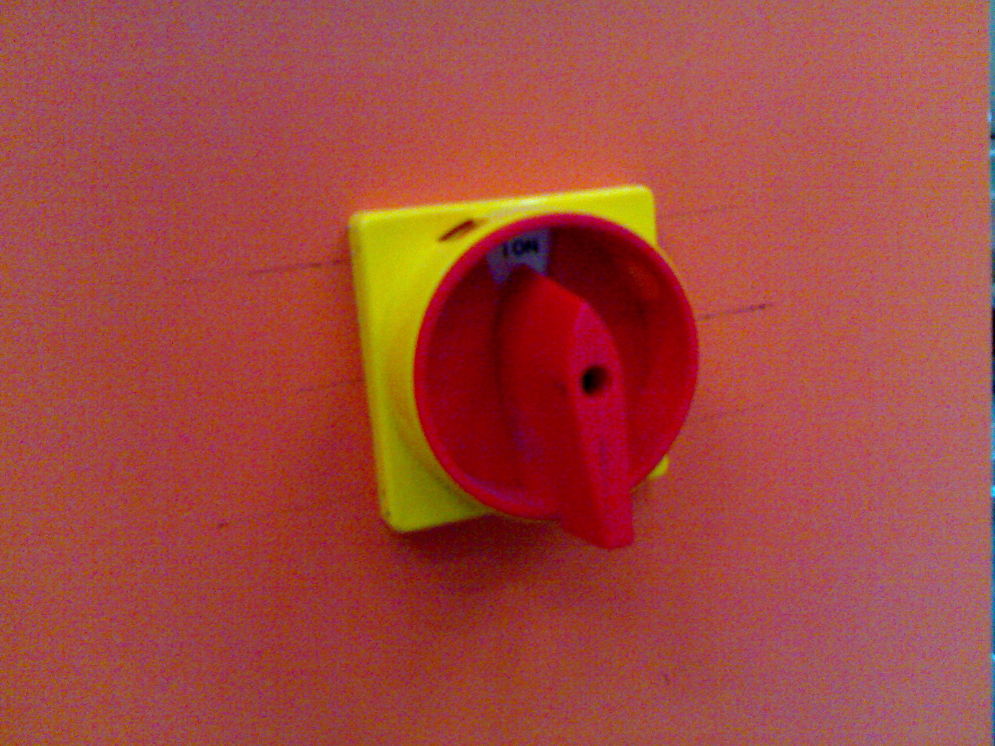
1

After electrical connection has been made, turn the Mains switch to ON position.
The Power indicator lamp will be lit. The timer displays will be ON and display the set values. If the RESET pushbutton is lit, then an Alarm condition is present.
If it is permanently lit, then the condition is still existing while if it is blinking, then the condition was present previously but not existing at the moment.
To reset the alarm condition, remove the alarm condition, set Conveyor Selector switch to OFF and then press RESET pushbutton.

4.2 Operator Panel

The operator panel consists of the following:

Item | Description | Function
1 | Main ON/OFF switch | This is used to switch on the main power to machine.
2 | Power ON Indicators | Indicates presence of mains supply
3 | Mains ON/OFF Switch | Used for starting the blower motor & Conveyor of the machine
4 | Switch ON/OFF HEATER | For switching the supply of Heater, which is interlocked with the blower.
5 | Temperature Controller | Used for Showing and adjusting the temperature inside the Heating Zone ( Chamber)
6 | POT for Conveyor Speed | Used for adjusting the speed of the conveyor.
7 | ASS (Selector Switch) | To check the current (load) given on 3 phase supply individually.
8 | AMMETER | Shows the current taken by phase as per selection

Components Make and Ratings:

Electrical Components:

Sr. No | Name of Component | Used for | Make | Rating | Qty Used
1 | MCB 4 POLE | Mains ON/OFF | Schneider | 63 AMP | 1 NO
3 | CONTACTOR | Conveyor and blower motor | Siemens | 9 AMP 230 V | 1 NOS
4 | CONTACTOR | Heater | Siemens | 63 AMP 230 V | 1 NO
5 | VFD for Conveyor Speed  (22FA2P5N103) | Conveyor Motor | ALLEN BRADELY | .37 KW 0.5 HP 2.5 AMPS  1 Ph In Put  3 Ph Out Put | 1 NO
6 | ON/OFF Switches &  ASS | Mains ON/OFF & Heater ON/OFF | Salazar L&T | 6 Amp | 2 NOS
7
8 | Indication Lamp (R,Y,B) | Supply Indication | Local |  | 3 NOS
9 | Temperature Controller | Temperature display and control | Solectron | TC-513 | 1 NO
10 | Blower Motor | Air Circulation | MMC ELECTRIC | 0.5 HP X 2800RPM X230V AC FLANCH (B5) | 2 NOS
11 | Conveyor Motor with Gear Box | Conveyor Running | MMC ELECTRIC | MI-AC/71B5-M(040)FL X 90 RPM | 1 NO

Chapter 5
Maintenance and Trouble-shooting

CAUTION

Maintenance must only be carried out by properly trained personnel.

All maintenance work must be carried out with the machine powered OFF and the plug disconnected from the mains power supply.

5.2 Trouble shooting

Problem | Possible cause | Suggested solution
Machine does not power ON | Mains supply not present | Check incoming supply and plug
Machine does not power ON | Fuse blown | Replace fuse
Machine does not power ON | Circuit breaker tripped | Check electrical components and heaters for fault
Roller conveyor belts do not move | Conveyor set to OFF | Set conveyor ON
Conveyor does not move | Drive roller rotates but belt does not move | Belt is loose, adjust tension roller to tighten it.
Conveyor does not move | Belt and drive roller move when pushed manually | Motor VFD Defective or Tripped
Conveyor does not move | Belt and drive roller do not move when pushed manually | Motor defective. Replace motor
Temperature does not rise | Heater is defective | Change corresponding heater
Temperature does not rise | Heater contactor defective | Change contactor
Temperature does not rise | Thermocouple defective | Replace thermocouple
Temperature does not rise | Temperature controller defective | Replace temperature controller

WEB SEALER CONTROLL PANEL
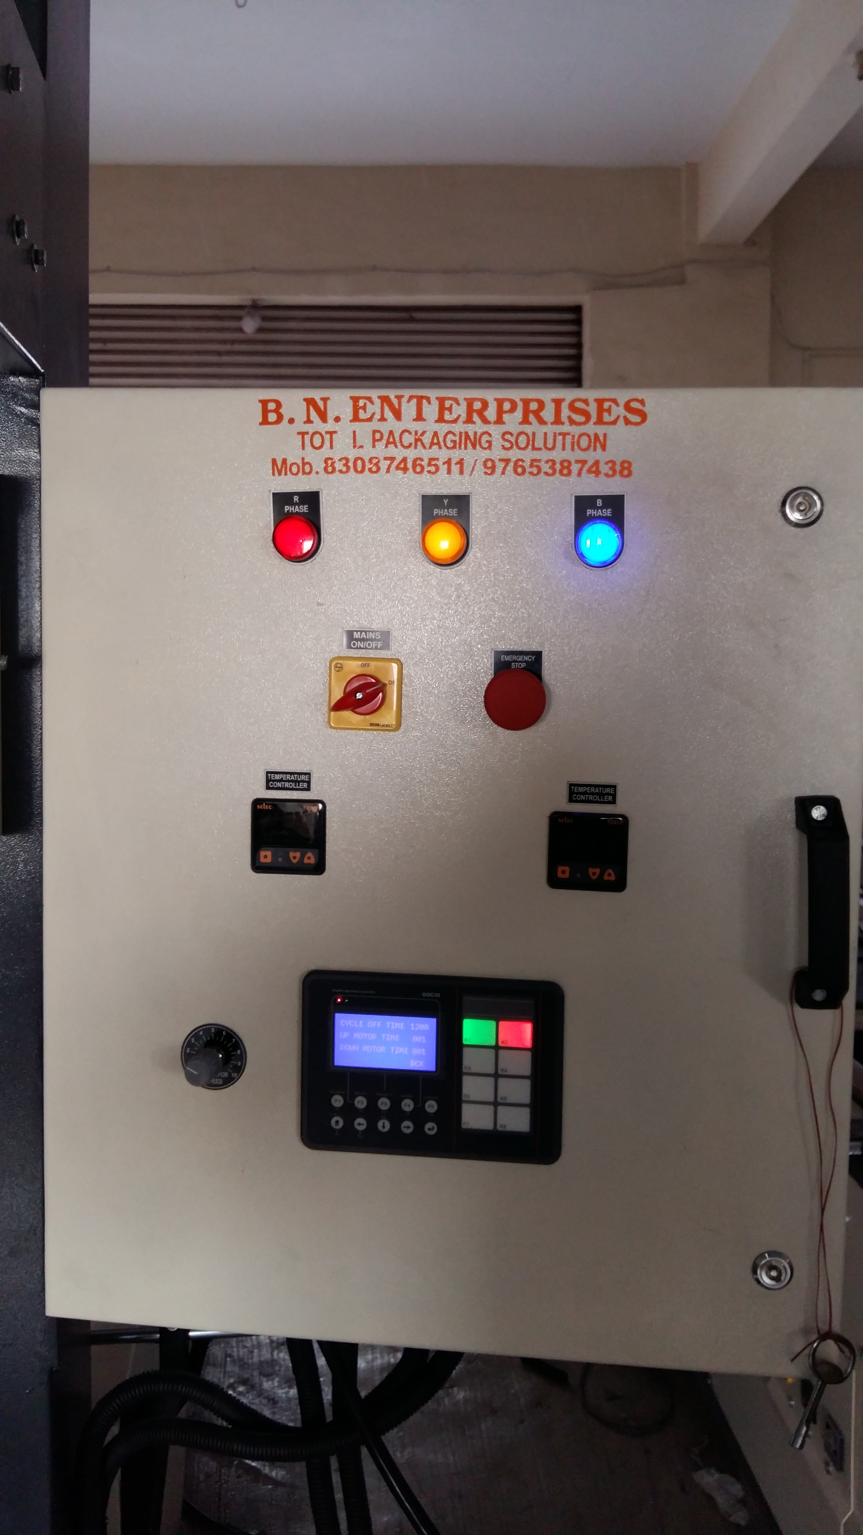

PLC WITHE HMI



